Criteria for Testing for COVID19
- Covenant Regional Lab cannot test for COVID19. The only current test availability is through the Health Department.
- To be accepted for COVID19 testing, the following requirements must be met: the CDC criteria below and have approval from the City Health Dept.
- *Please note that the travel history includes domestic travel to areas of local transmission as well
  - 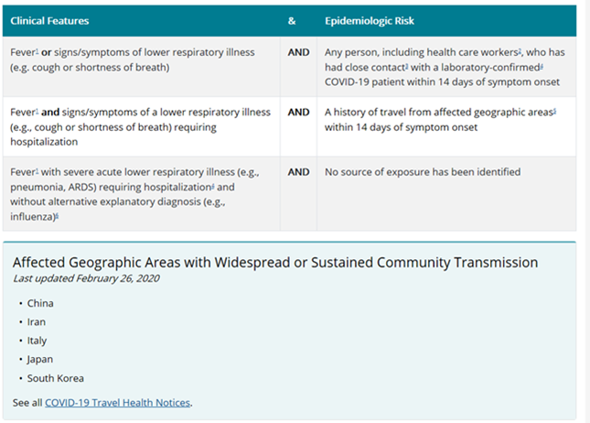
- The Lubbock City Health Dept asks that a Viral Respiratory PCR panel, Influenza and Strep screens be run and negative before calling Health Department.
- City Health Dept # include
  - Day time M-F 8-5pm 806 775-2933
  - Weekends and After hours 806-741-7093
- The COVID19 Order can be found in Meditech by searching for either corona or covid:

